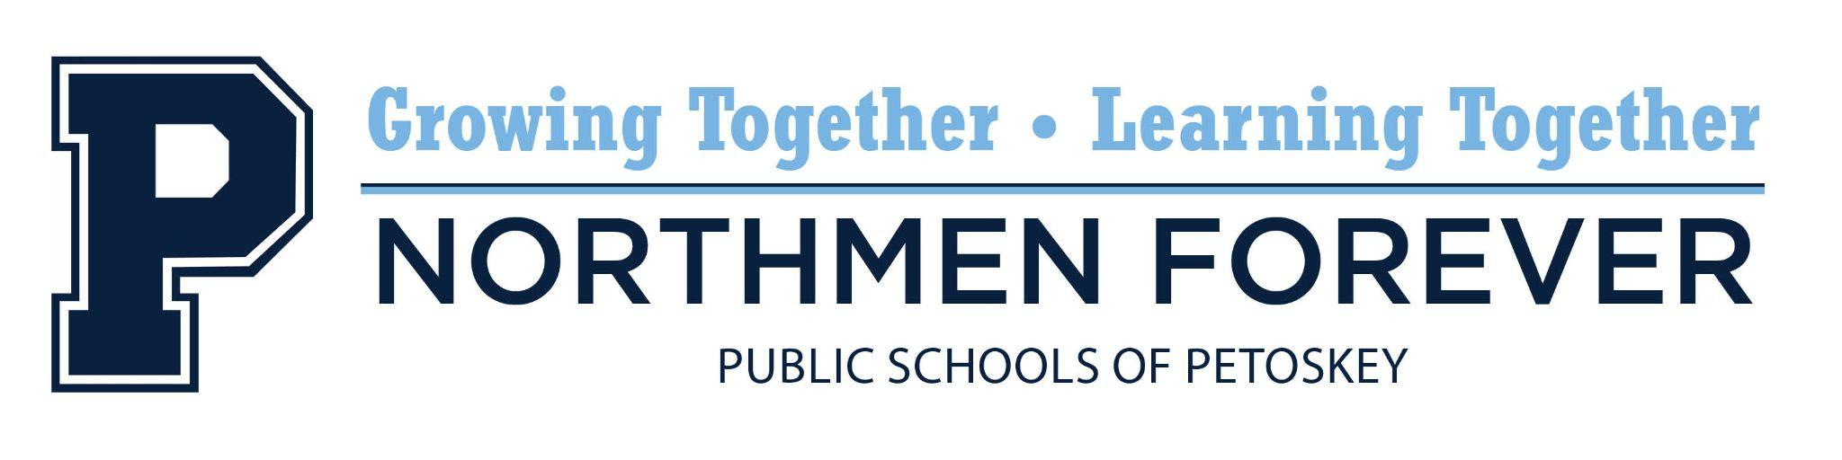

**Regular School Board Meeting**

Tuesday, July 15, 2025 6:00 PM

Spitler Administration Building, 1130 Howard Street, Petoskey, MI 49770

**AGENDA**

1. Call to Order and Roll Call
2. The Pledge of Allegiance
3. Organizational Meeting
4. Resolution: Approval - Bank Authorization
5. Resolution: Approval - Delegation of Authority, Chief Election Officer
6. Resolution: Approval - Delegation of Authority, Investment of Funds
7. Resolution: Approval - Designation of Depositories
8. Regular Meeting
9. Audience Participation
10. Presentation: Food Service Update
11. Resolution: Approval - Minutes

* Regular Meeting Minutes, June 17, 2025
* Special Meeting Minutes, July 7, 2025
* Closed Session Meeting Minutes, July 7, 2025 (walk-in)

1. Resolution: Approval - Warrants
2. Resolution: Approval - PESPA Three-Year Labor Contract
3. Resolution: Approval - Superintendent Evaluation Summary
4. Resolution: Approval - 2025 Annual Policy Updates
5. Discussion: Northmen Mascot / Logo
6. Educational Reports
7. Board of Education Reports
8. Financial Report
9. Superintendent’s Report
10. Audience Participation
11. Adjournment

"The mission of the Public Schools of Petoskey is to advance the education and skills of all students in an equitable manner through the participation and involvement of staff, students, parents, and others in the community.”

Participation by the audience is welcomed and encouraged. Please note that this time is for Board members to listen to public comment, not to respond to comments. Two opportunities for public comment are provided at each Board meeting. When participating in public comment, members of the audience are to identify themselves by name and address so that accurate minutes can be recorded. Unless permission is previously received from the Board of Education, comments are to be limited to three (3) minutes per person. For those people who prefer not to speak at the Board meeting yet want their question(s) or comment(s) conveyed to Board members, a (green) "Memo to the Board" form is provided in the basket near the entrance of the meeting room. Please note that public comment time and the "Memo to the Board" are provided to allow Board members to listen to public comment, not respond to comments or concerns.