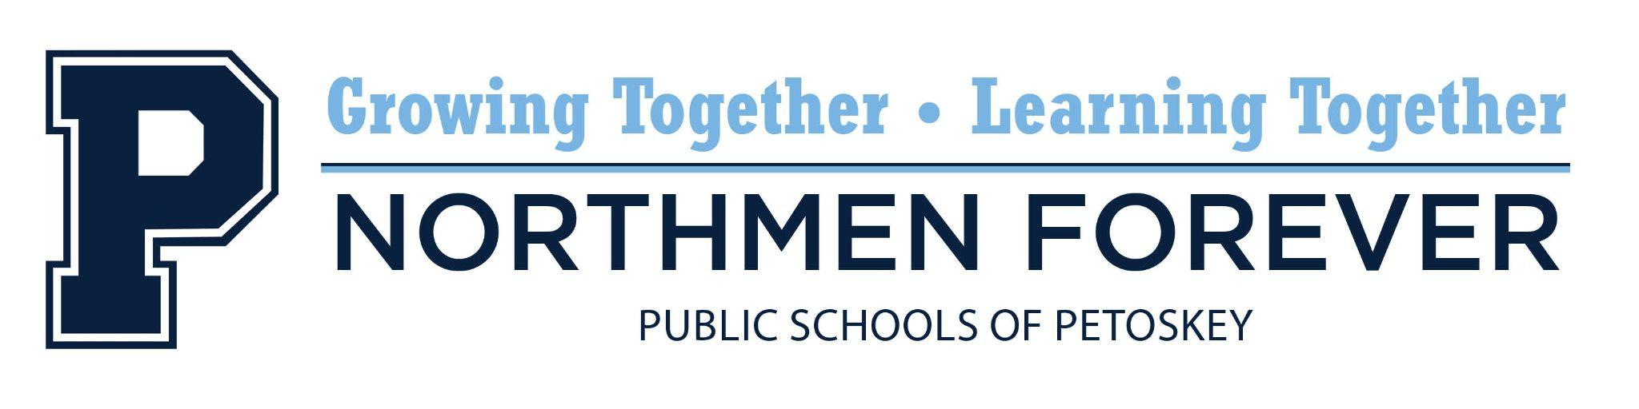

**Regular School Board Meeting**

Tuesday, June 17, 2025, 6:00 PM

Spitler Administration Building, 1130 Howard Street, Petoskey, MI 49770

**AGENDA - REVISED**

1. Budget Hearing
2. Call to Order and Roll Call
3. The Pledge of Allegiance
4. Recognition: Professional Staff Retiree Recognition
5. Audience Participation
6. Presentation - Northmen Mascot / Logo Update
7. Resolution: Approval - Minutes

* Regular Meeting Minutes, May 14, 2025
* Closed Session Meeting Minutes, May 14, 2025 (walked in)
* Special Meeting Minutes, June 2, 2025
* Special Meeting Minutes, June 16, 2025
* Closed Session Meeting Minutes, June 16, 2025 (walked in)

1. Resolution: Approval - Warrants
2. Resolution: Approval - Employment Recommendations
3. Resolution: Approval - Administrator Salary Schedule Revision
4. Resolution: Approval - Administrator Contract Extension
5. Resolution: Approval - Superintendent Evaluation
6. Resolution: Approval - Superintendent Contract Extension
7. Resolution: Approval - State of Emergency Forgiveness
8. Resolution: Approval - MHSAA Renewal
9. Resolution: Approval - Sale of Building Trades House
10. Resolution: Approval - 24-25 Student Activity Fund Budget
11. Resolution: Approval - 25-26 Student Activity Fund Budget
12. Resolution: Approval - 25-26 General Fund Budget
13. Resolution: Approval - 25-26 Food Service Fund Budget
14. Resolution: Approval - 25-26 Sinking Fund Budget
15. Discussion: NWEA Spring Testing Data
16. Educational Reports
17. Board of Education Reports
18. Financial Report
19. Superintendent’s Report
20. Audience Participation
21. Adjournment

"The mission of the Public Schools of Petoskey is to advance the education and skills of all students in an equitable manner through the participation and involvement of staff, students, parents, and others in the community.”

Participation by the audience is welcomed and encouraged. Please note that this time is for Board members to listen to public comment, not to respond to comments. Two opportunities for public comment are provided at each Board meeting. When participating in public comment, members of the audience are to identify themselves by name and address so that accurate minutes can be recorded. Unless permission is previously received from the Board of Education, comments are to be limited to three (3) minutes per person. For those people who prefer not to speak at the Board meeting yet want their question(s) or comment(s) conveyed to Board members, a (green) "Memo to the Board" form is provided in the basket near the entrance of the meeting room. Please note that public comment time and the "Memo to the Board" are provided to allow Board members to listen to public comment, not respond to comments or concerns.